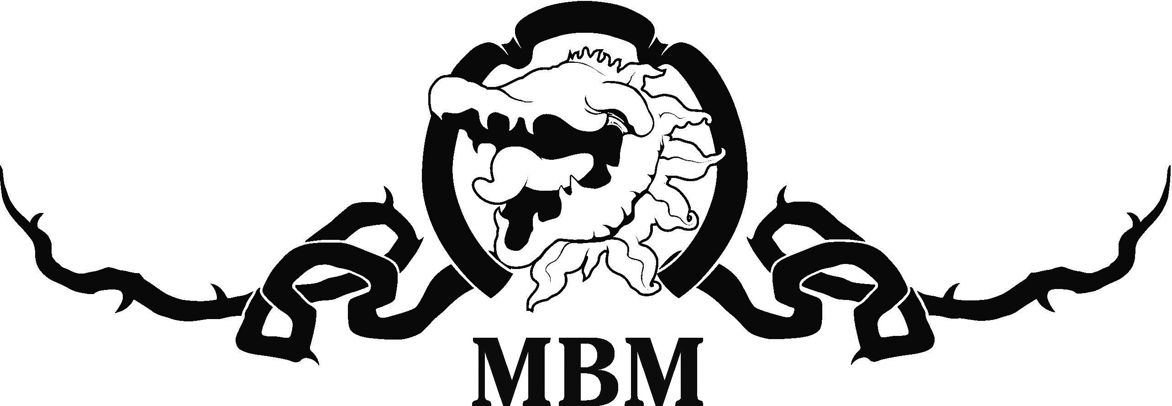 PRESS RELEASE

New Fringe home for Matt Byrne’s Vegans in Norwood

Matt Byrne’s Vegans is a foodie comedy to diet for, for the 2020 Adelaide Fringe!

And it will be in a new Fringe home in the Don Pyatt Hall next to the Norwood Town Hall, from February 11 to March 14 at 8 p.m.

Writer/director Matt Byrne is delighted with the new venue and says Vegans will be prove a topical taste test for Fringegoers, “but beware, there are traces of nuts!”

“After 22 crazy years at Maxim’s Wine Bar we have moved across The Parade to a terrific new home for the World Premiere of a nutritional comedy with plenty of bite,” Byrne said.

“Matt Byrne’s Vegans will take a riotous look at what Australians eat and what’s eating Australians when it comes to food and lifestyle choices. We’re moving from sizzlings steaks to mock meat and mocking meat, and even the humble Aussie BBQ may be under fire!”

Byrne said the Vegan movement had opened a can of inedible worms for society.

“Going Vegetarian meant a change of diet, but Vegans are living a whole new moral code,” he said. “The theory sounds good but the practical demands make inviting people over for dinner or a bbq, a whole new nightmare.

“Many people now have dietary requirements, and with the rise of diabetes many of us are now watching what we eat a lot more closely. Is being Vegan sustainable and what’s on the menu for the future? Come and have a laugh and some food for thought, with a show that has the right recipe for fun!”

Byrne will play market guru Greenie Thumbs, Lauren Weber will play Tegan the Vegan, Jayke Melling will play Gluten Free III and Adam D’Apice will play Meat Lovers in a show that has something for all tastes.

“They are our main roles but we will each play at least a dozen other characters from the foodie universe – and it happens in the blink of an eye!”

Matt Byrne’s Vegans will celebrate 23 incredible years of MBM presenting Fringe comedies at Norwood.

“We’ve had great success with shows like Barrackers, Pricks, Virgins, Chalkies, PIGS, Bogans, The Luv Boat, My Kitchen Fools, Hott Property and Married At First Fight at Maxim’s,” he said.

“But the Don Pyatt Hall is even more accessible and is at ground level, right next to the Norwood Concert Hall. You enter off George Street and the seating is excellent and we will run the bar, so you can grab a drink and enjoy the show!”

Matt Byrne’s Vegans will play the Don Pyatt Hall at 175 The Parade, Norwood (enter off George Street), from February 11 ($18 Preview) 12-15, 19-22, February 27 to 29, and March 4-7 & 11-14 at 8:00 p.m. All Tix are $28, plus booking fee.

Book on 1300 621 255, fringetix.com.au, 8262 4906 or mattbyrnemedia.com.au
“The Fringe wouldn’t be complete without an MBM four-hander at Norwood, written and produced by local theatre identity Matt Byrne!” – Adelaide Theatre Guide.

